Lambert Model

📘 Definition
# Source: AI Source: Provided by: [Data Path: Persons Table -> ID Column: 1, Name_En Column: Motasem Essam] -> From: [ChatGPT] on [5/2/2026]
The Lambert Model (also called Lambertian shading) is a basic lighting model in computer graphics that shows how light behaves on a rough, matte surface.
It calculates brightness based only on how directly light hits a surface—no shine, no reflections.

💡 How Lambert Model works
# Source: AI Source: Provided by: [Data Path: Persons Table -> ID Column: 1, Name_En Column: Motasem Essam] -> From: [ChatGPT] on [5/2/2026]

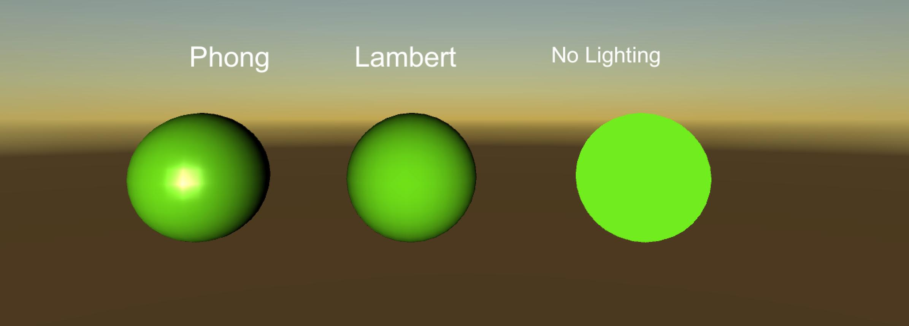
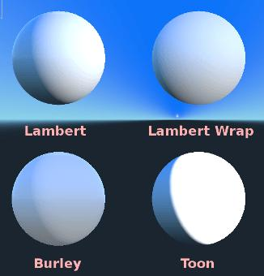
- Light hits a surface
- The brightness depends on the angle of light
- More direct light → brighter surface
- Less direct light → darker surface
- No shiny highlights are added

🧠 Simple example
# Source: AI Source: Provided by: [Data Path: Persons Table -> ID Column: 1, Name_En Column: Motasem Essam] -> From: [ChatGPT] on [5/2/2026]
Think of:
- 📄 A paper sheet under a lamp → evenly lit, no shine
- 🧱 A brick wall → looks flat and non-reflective

🎮 Where Lambert Model is used
# Source: AI Source: Provided by: [Data Path: Persons Table -> ID Column: 1, Name_En Column: Motasem Essam] -> From: [ChatGPT] on [5/2/2026]
- 🎮 Basic lighting in video games
- 🧑‍💻 3D modeling previews
- 🧪 Scientific visualization
- 🎨 Matte materials (clay, fabric, chalk)

⚙️ Key features
# Source: AI Source: Provided by: [Data Path: Persons Table -> ID Column: 1, Name_En Column: Motasem Essam] -> From: [ChatGPT] on [5/2/2026]
- 🌫️ Only diffuse lighting
- 🚫 No shiny reflections (no specular light)
- 📏 Brightness depends on light angle
- 🎯 Simple and fast to compute

🚀 In short:
# Source: AI Source: Provided by: [Data Path: Persons Table -> ID Column: 1, Name_En Column: Motasem Essam] -> From: [ChatGPT] on [5/2/2026]
Lambert Model = a lighting model that shows how light spreads on matte surfaces without any shine or reflections.

